

**SIMPLON’S BEAUTY CARE CENTER**

|  |  |  |
| --- | --- | --- |
| **Supervisr:** | *LÊ THANH NHÂN* | |
| **Semester:** | *01* | |
| **Batch No:** | *T1.2012.E1* | |
| **Group No:** | *05* | |
| **Order:** | **Full name** | **Roll No.** |
| *1.* | *NGUYEN VU* | *Student1295178* |
| *2.* | *NGUYEN DUY THANH* | *Student1295179* |
| *3.* | *TANG TRUONG THAI* | *Student1295176* |

***Month****: 04* ***Year****: 2021*



This is to certify that

|  |  |
| --- | --- |
| **Mr.** | **NGUYEN VU** |
| **Mr.** | **NGUYEN DUY THANH** |
| **Ms.** | **TANG TRUONG THAI** |

Have successfully Designed & Developed

|  |  |  |
| --- | --- | --- |
|  |  |  |
| **SIMPLON’S BEAUTY CARE CENTER** | | |

Submitted by:

|  |
| --- |
| **Mr. LE THANH NHAN** |

Date Of Issue:

|  |  |
| --- | --- |
|  |  |

Authorized Signature:

|  |  |
| --- | --- |
|  |  |

|  |
| --- |
| **Content** |

Content

Acknowledge

Synposis

Review1 (Fill in the actual page number)

Review2 (Fill in the actual page number)

Review3 (Fill in the actual page number)

Testting Document (Fill in the actual page number)

Final Checklist (Fill in the actual page number)

Tasksheet (Fill in the actual page number)

|  |
| --- |
| **Acknowledge** |

We are group 5 in class T1.2012.E1 from FPT Aptech, and we are respectfully thank you to all the opportunity that the school has given us all the chance to have an ability to connect with teacher Team, staff and tech staff from the school. Especially Mr. Nguyen and Mr. Nhan which is our ex and currently teacher during the course.

During the time that we are studying in FPT Aptech, we found out that there are a lot of meaningful people doing meaningful thing in the community to help and contribute for the school, the society and for those student who haven’t know anything about coding and technology yet to be able to learn how to code.

In our philosophy, we think that learning code is very good and it teach people how to think! We are very thankful for that. Also, for student like us, we haven’t know anything about coding yet but in a world that’s changing very quickly right now, the most important thing is information. The reason for that is because the digital age was and are dominancing the humanity life a lot. You might be smart today but you also might turn out fall back from the other by tomorrow. Learning how to code is very important. Because first, it teach you how to think, and secondly programming and building thing are creating a lot of value for people and for community.

So we are very thankful for the time that our teacher has spend and give us a lot of advice and responsibility for our course

Your Sincerely,

Team Group Symplon

|  |
| --- |
| **Synposis** |

The Objective of this program we aim is to give a sample project to work on real life projects. These applications help us build a larger more robust application.

The objective is not to teach us HTML/JavaScript but to provide us with a real life scenario and help us create basic applications using the tools.

This project is meant for students like us who have completed the module of HTML5. These programs are done following group with assistance of an adviser.

SIMPLON’s Beauty care centre is very big shop of cosmetics and accessories in the city, we will build a cosmetics sales website that shows the true scale of it, which is showing:

* The Home Page created with proper sections, graphics and with asuitable logo.
* A “Categories” contents have various kind of lights such as: HAIR, SKIN, MAKE-

UP KITS, NAIL PAINTS, NAIL ARTS, JEWELLRY, WEDDING KITS,…where consumers should find it easy to view various products and decide upon purchasing the right product to meet their requirements.

* A “Feedback” area should be added within the website for increasing the interaction between consumers and suppliers.
* Consumers can become a member by filling a form in “Member Registration”. The website will automatically send new letters to them for new arrival products or promotion program if any.
* Use GeoLocation API to show the address or location of SIMPLON’s Beautycare centre on the maps.

It is very essential for us that will have a clear understanding of the subject. We think we should go through the project and solve the assignments as per requirements given.

And get back ***eprojects@aptech.ac.in*** as the assigned schedule.

|  |
| --- |
| **Problem Definition** |

SIMPLON’s Beauty care centre is very big shop of cosmetics and accessories in the city. With the success of the shop, owner had opened few more shops in the different cities also. Simplon product is known for their quality of the service which they are providing since 1985. In order to advertize about the company and also to start online services the company wishes to make the website of the company.

For which they have approach you to design the website and requirement specification for the same is given below:

The website is to be developed for the Windows Platform using HTML5, JavaScript and Geolocation. The site should work well in all leading browsers including Chrome, IE, Firefox etc.

**Requirement Specification:**

The Web site is to be created based on the following requirements.

1. The Home Page should be created with proper sections, graphics and with a suitable logo.
2. The look and feel of the project must be made user friendly and uniformity in the color combination must be maintained.
3. About us, Contact Us (address and map) must be added. In the Contact Us page the website of all the shops location must be given.
4. All the categories of the products like HAIR, SKIN, MAKE-UP KITS, NAIL PAINTS, NAIL ARTS, JEWELLRY, WEDDING KITS, UPCOMING PRODUCTS & so on. For each product the cost must be mentioned in the list.
5. Feedback page must be added to take the valuable feedback from the users.
6. Contact Us, About Us.
7. Use GeoLocation API to show the address or location of SIMPLON’s Beauty care centre on the maps.
8. Gallery section can be included.
9. Navigation of the project must be made user friendly.
10. Customer must be allowed to place the order by selecting the product.
11. While placing the dummy order, the total cost of the order must be calculated.

|  |
| --- |
| **Customer Requirements Specifications** |

**User:**

**Input:**

* Input username
* Input password
* Input confirm password

**Process:**

* Process valid username
* Process valid password
* Check password

**Output:**

* Output register information
* Output success notification

|  |  |
| --- | --- |
| **Webmaster:** | |
|  | |
|  | **Input:** |
| Input username |  |
| Input password |  |
| Input key |  |
|  | **Process:** |
| Process valid username |  |

|  |
| --- |
| **Hardware / software requirement:**  **Software:**   * Notepad/HTML editor * Dreamweaver * IE 5.0/Netscape 6.0   **Hardware:**  - A minimum computer system that will help you access all the tools in the courses is a Pentium 166 or better - 64 Megabytes of RAM or better |

|  |
| --- |
| **Architecture and design of the project** |

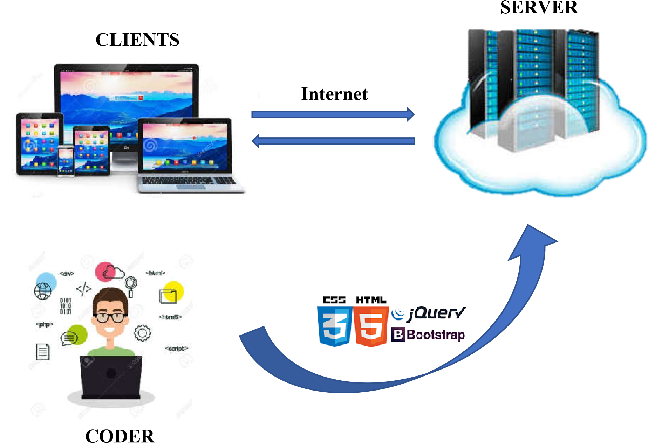

|  |
| --- |
| **SiteMap** |

Home page

Hair skin

Nail pants

Make

-

up kits

Nail arts

Jewellry

Upcoming products

Wedding kits

Search

Products

About Us

Contact Us

Register

Login

|  |
| --- |
| **Screen shots** |

**Description** : This is display hompage

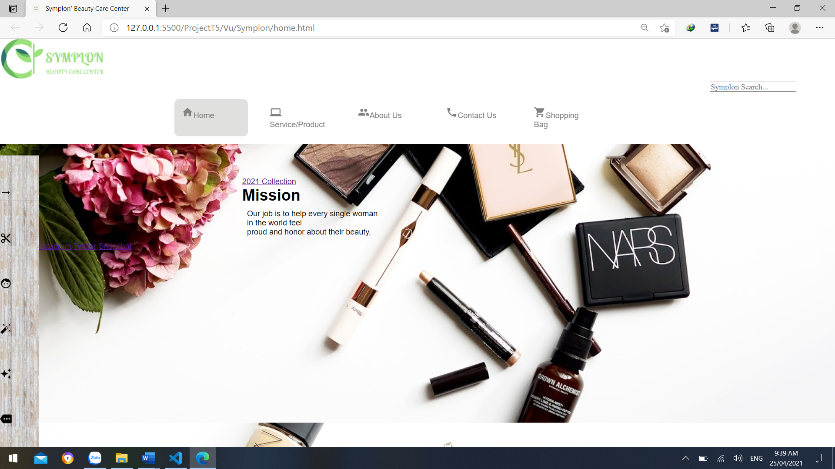

**From** : SymPlons’s Beauty Care Center

**To** : You can switch from the homepage to sites like Service / Product and About us

|  |
| --- |
| **Testing document** |

|  |  |  |
| --- | --- | --- |
| **Sr.No** | **Features Tested** | **Remarks** |
| 1 |  |  |
| 2 |  |  |
| 3 |  |  |
| 4 |  |  |
| 5 |  |  |
| 6 |  |  |
| 7 |  |  |
| 8 |  |  |
| 9 |  |  |
| 10 |  |  |
| 11 |  |  |
| 12 |  |  |
| 13 |  |  |
| 14 |  |  |
| 15 |  |  |

|  |
| --- |
| **Final checklist** |

|  |  |  |
| --- | --- | --- |
| **Sr.No** | **Aspected Tested** | **Suggestion/**  **Remarks** |
| 1 | Are all the users able to view the images and links? |  |
| 2 | Have all the views, modules and controllers been properly integrated and is the site function as a single page application? |  |
| 3 | Are the GUI content devoid of spelling mistakes? |  |
| 4 | Is the application user-friendly? |  |
| 5 | Is the Website launching correctly in all popular browsers? |  |
| 6 | Are all the forms validated with proper criteria? |  |
| 7 | Do all text links lead to the appropriate website? |  |
| 8 | Do all image links lead to the appropriate website? |  |
| 9 | Are all the images and links clearly visible on the page? |  |
| 10 | Does the Web page work properly in all the tested browsers? |  |
| 11 | Does the Web page take too long to be loaded fully? |  |
| 12 | Is the navigation sequences correct through all the Web pages on the site? |  |
| 13 | Is the JavaScript code working as expected in all click events? |  |
|  |  |  |
|  | (Sinh viên ghi thêm…) |  |

|  |  |  |  |  |  |  |  |
| --- | --- | --- | --- | --- | --- | --- | --- |
| **No** | **Member** | **Contents** | **Page Name** | **Activity Plan** | **Date of Preparation of Activity Plan** | | |
| **Planed Start Date** | **Actual Start Date** | **Actual Days** | **Status** |
| 1 | NGUYEN VU | Hompage | Hompage.html | 10-04-2021 | 10-04-2021 | 5 | OK |
| 2 | Categories | Categories.html | 10-04-2021 | 10-04-2021 | 5 | OK |
|  |  | Search | Search.html | 10-04-2021 | 10-04-2021 |  |  |
|  | | | | | | | |
| 1 | NGUYEN DUY THANH | Service/Product | Product.html | 10-04-2021 | 10-04-2021 | 5 | OK |
| 2 | About us | Abou tus.html | 10-04-2021 | 10-04-2021 | 5 | OK |
|  | | | | | | | |
| 1 | TANG TRUONG THAI | Geolocation | Geolocation.html | 10-04-2021 | 10-04-2021 | 5 | OK |
| 2 | Register | Register.html | 10-04-2021 | 10-04-2021 | 5 | OK |